(This is in booklet format, to be read left column to right
then top to bottom)

Installation Service

Prayers Before Service…Gracious Lord, You instituted the Office of the Holy Ministry that Your kingdom of grace and Truth would continue and grow in the world. Bless our pastor and all pastors that they may grow and continue in Your truth by the ongoing power of the Holy Spirit through the means of grace and bring these gifts to bear in the lives of Your people to their welfare and the glory of Your holy name, Father, Son, and Holy Spirit. Amen.

Service of Prayer and Preaching Page 260

Opening Hymn: “Alleluia! Jesus Is Risen” LSB # 474
1 Alleluia! Jesus is risen!
Trumpets resounding in glorious light!
Splendor, the Lamb, Heaven forever!
Oh, what a miracle God has in sight! Refrain

Refrain Jesus is risen and we shall arise:
Give God the glory! Alleluia!

2 Walking the way, Christ in the center
Telling the story to open our eyes;
Breaking our bread, Giving us glory:
Jesus our blessing, our constant surprise. Refrain

3 Jesus the vine, We are the branches;
Life in the Spirit the fruit of the tree;
Heaven to earth, Christ to the people,
Gift of the future now flowing to me. Refrain

4 Weeping, be gone; Sorrow, be silent:
Death put asunder, and Easter is bright.
Cherubim sing: “O grave, be open!”
Clothe us in wonder, adorn us in light. Refrain

5 City of God, Easter forever,
Golden Jerusalem, Jesus the Lamb,
River of life, Saints and archangels,
Sing with creation to God the I AM! Refrain
Stand

Opening Versicles
P: This is the day which the Lord has made;
C: let us rejoice and be glad in it.
P: From the rising of the sun to its setting,
C: the name of the Lord is to be praised.

P: Better is one day in Your courts than a thousand elsewhere;
C: I would rather be a doorkeeper in the house of my God than dwell in the tents of the wicked.
P: Make me to know Your ways, O Lord.
C: Teach me Your paths.
P: Sanctify us in You truth.
C: Your Word is truth.

P: From the rising of the sun to its setting,
C: the name of the Lord is to be praised.

C: Glory be to the Father and to the Son and to the Holy Spirit;
as it was in the beginning, is now, and will be forever. Amen.

Old Testament Canticle
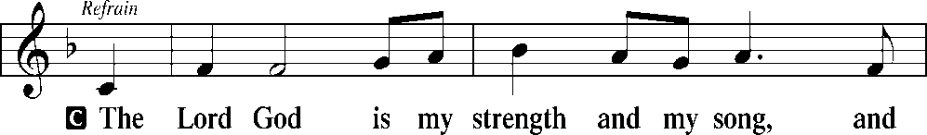
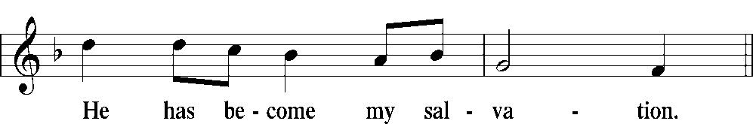
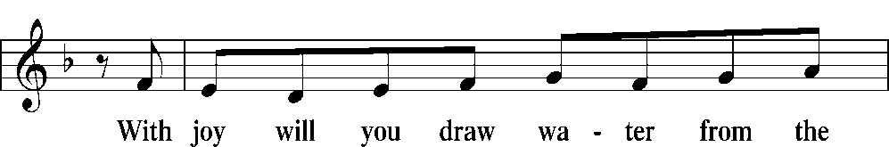
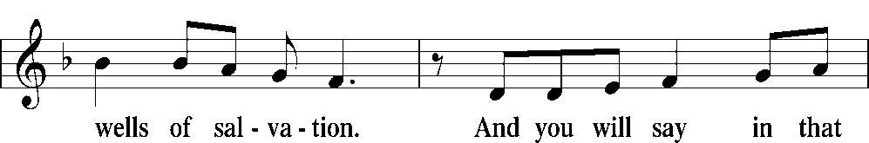
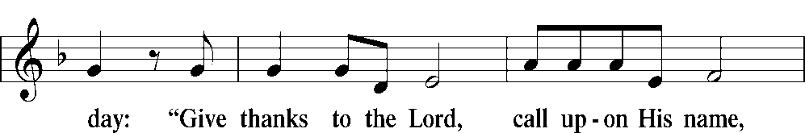
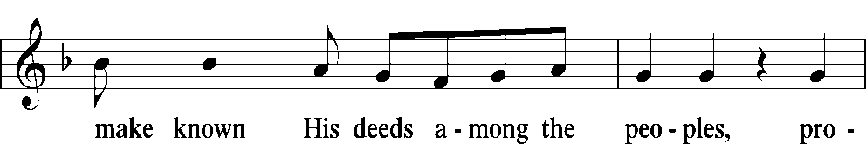
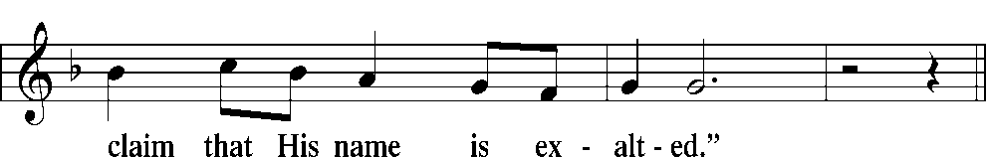
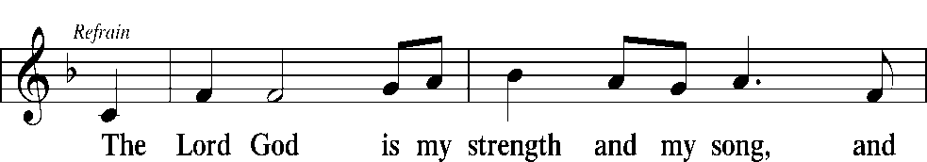
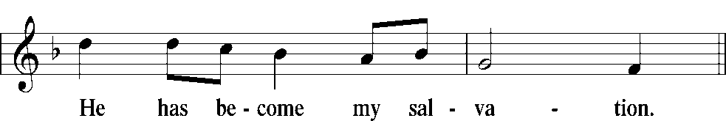
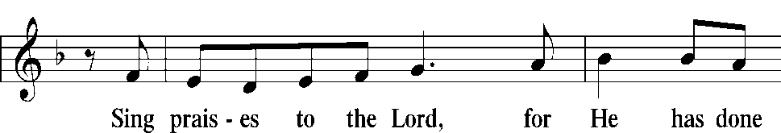
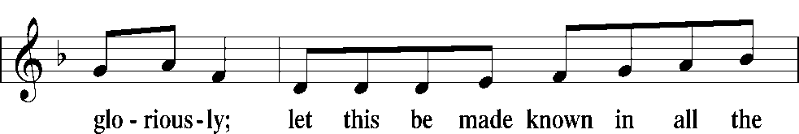
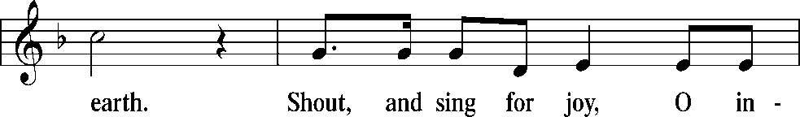
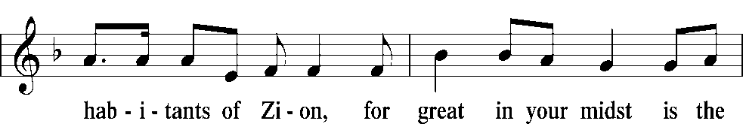
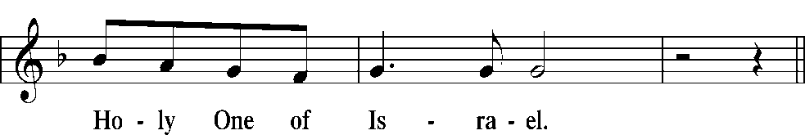
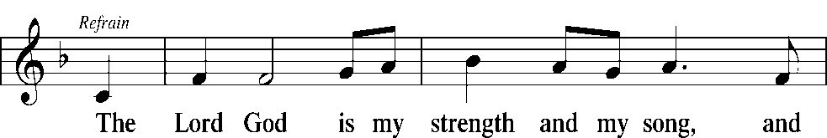
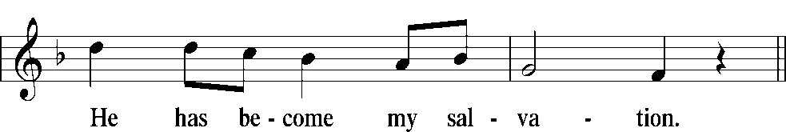
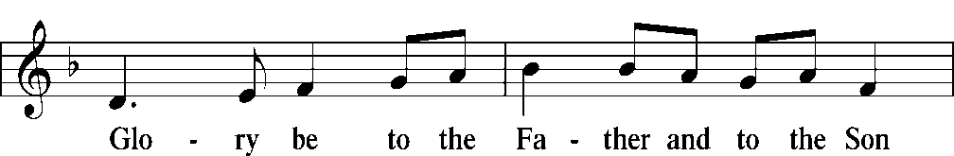
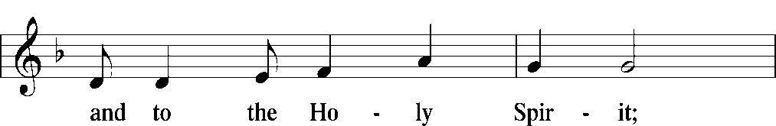
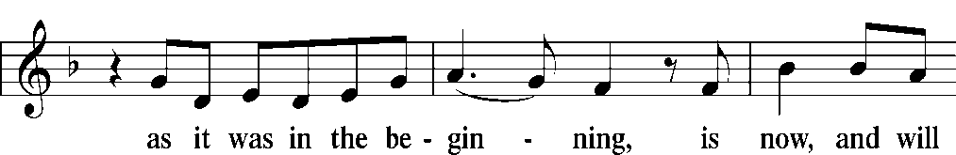
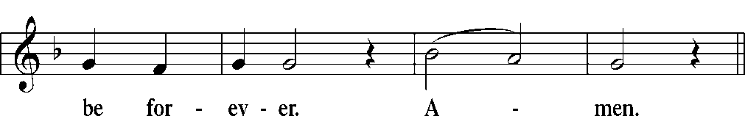
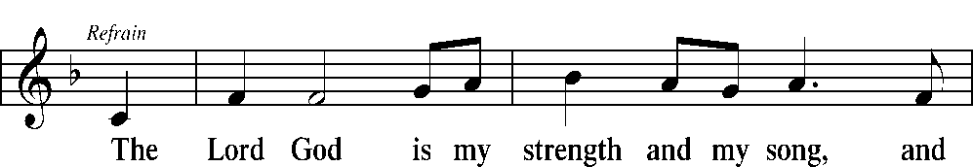
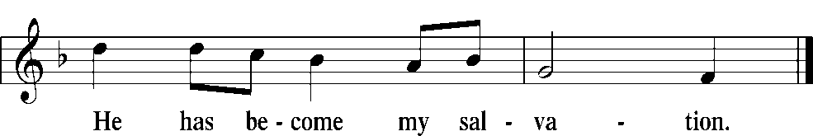

Old Testament Reading Jeremiah 1:9-10, 17-19
Then the Lord put out his hand and touched my mouth. And the Lord said to me,
“Behold, I have put my words in your mouth. See, I have set you this day over nations and over kingdoms, to pluck up and to break down, to destroy and to overthrow, to build and to plant.”
But you, dress yourself for work; arise, and say to them everything that I command you. Do not be dismayed by them, lest I dismay you before them. And I, behold, I make you this day a fortified city, an iron pillar, and bronze walls, against the whole land, against the kings of Judah, its officials, its priests, and the people of the land. They will fight against you, but they shall not prevail against you, for I am with you, declares the Lord, to deliver you.”
P: This is the Word of the Lord.
C: Thanks be to God.

Psalm 119:89–96
P: Forever, O Lord,
C: Your word is firmly fixed in the heavens.
P: Your faithfulness endures to all generations;
C: You have established the earth, and it stands fast.
P: By Your appointment they stand this day,
C: for all things are Your servants.
P: If Your law had not been my delight,
C: I would have perished in my affliction.
P: I will never forget Your precepts,
C: for by them You have given me life.
P: I am Yours; save me,
C: for I have sought Your precepts.
P: The wicked lie in wait to destroy me,
C: but I consider Your testimonies.
P: I have seen a limit to all perfection,
C: but Your commandment is exceedingly broad.
Glory be to the Father and to the Son
and to the Holy Spirit;
as it was in the beginning,
is now, and will be forever. Amen.

Epistle Reading Ephesians 4:1-7, 11-16

I therefore, a prisoner for the Lord, urge you to walk in a manner worthy of the calling to which you have been called, with all humility and gentleness, with patience, bearing with one another in love, eager to maintain the unity of the Spirit in the bond of peace. There is one body and one Spirit—just as you were called to the one hope that belongs to your call— one Lord, one faith, one baptism,⁶one God and Father of all, who is over all and through all and in all. But grace was given to each one of us according to the measure of Christ’s gift.
And he gave the apostles, the prophets, the evangelists, the pastors and teachers, to equip the saints for the work of ministry, for building up the body of Christ, until we all attain to the unity of the faith and of the knowledge of the Son of God, to mature manhood, to the measure of the stature of the fullness of Christ, so that we may no longer be children, tossed to and fro by the waves and carried about by every wind of doctrine, by human cunning, by craftiness in deceitful schemes. Rather, speaking the truth in love, we are to grow up in every way into him who is the head, into Christ, from whom the whole body, joined and held together by every joint with which it is equipped, when each part is working properly, makes the body grow so that it builds itself up in love.
P: This is the Word of the Lord.
C: Thanks be to God.

Stand

Holy Gospel Reading John 20:19-23

P: The Holy Gospel according to St. John, the 20th chapter.
C: Glory to You, O Lord.

On the evening of that day, the first day of the week, the doors being locked where the disciples were for fear of the Jews, Jesus came and stood among them and said to them, “Peace be with you.” When He had said this, He showed them His hands and His side. Then the disciples were glad when they saw the Lord. Jesus said to them again, “Peace be with you. As the Father has sent Me, even so I am sending you.” And when He had said this, He breathed on them and said to them, “Receive the Holy Spirit. If you forgive the sins of anyone, they are forgiven; if you withhold forgiveness from anyone, it is withheld.”
P: This is the Gospel of the Lord.
C: Praise to You, O Christ.

Responsory
P: Forever, O Lord, Your Word is firmly set in the heavens.
C: Lord, I love the habitation of Your house and the place where Your glory dwells.
P: Blessed are those who hear the Word of God and keep it.
C: Lord, I love the habitation of Your house and the place where Your glory dwells.
P: Glory be to the Father and to the Son and to the Holy Spirit.
C: Lord, I love the habitation of Your house and the place where Your glory dwells.

Catechism: Taken from Martin Luther’s Preface to the Large Catechism

Apostles’ Creed

C: I believe in God, the Father Almighty,
maker of heaven and earth.

And in Jesus Christ, His only Son, our Lord,
who was conceived by the Holy Spirit,
born of the virgin Mary,
suffered under Pontius Pilate,
was crucified, died and was buried.
He descended into hell.
The third day He rose again from the dead.
He ascended into heaven
and sits at the right hand of God the Father Almighty.
From thence He will come to judge the living and the dead.

I believe in the Holy Spirit,
the holy Christian Church,
the communion of saints,
the forgiveness of sins,
the resurrection of the body,
and the life † everlasting. Amen.

Lord's Prayer

C: Our Father who art in heaven,
hallowed be Thy name,
Thy kingdom come,
Thy will be done on earth
as it is in heaven;
give us this day our daily bread;
and forgive us our trespasses
as we forgive those
who trespass against us;
and lead us not into temptation,
but deliver us from evil.
For Thine is the kingdom
and the power and the glory
forever and ever. Amen.

Sit

Sermon: By Rev. Paul Sajban

Sermon Hymn: “The Gifts Christ Freely Gives” LSB # 602

Order of Installation: At this point in the service the newly installed
Pastor continues with the service.

Prayer
P: In peace let us pray to the Lord:
C: Lord, have mercy.
P: For the gift of divine peace and of pardon, with all our heart and with all our mind, let us pray to the Lord:
C: Lord, have mercy.
P: For the holy Christian Church, here and scattered throughout the world, and for the proclamation of the Gospel and the calling of all to faith, let us pray to the Lord:
C: Lord, have mercy.
P: For this nation, for our cities and communities, and for the common welfare of us all, let us pray to the Lord:
C: Lord, have mercy.
P: For seasonable weather and for the fruitfulness of the earth, let us pray to the Lord:
C: Lord, have mercy.
P: For those who labor, for those whose work is difficult or dangerous, and for all who travel, let us pray to the Lord:
C: Lord, have mercy.
P: For all those in need, for the hungry and homeless, for the widowed and orphaned, and for all those in prison, let us pray to the Lord:
C: Lord, have mercy.
P: For the sick and dying and for all those who care for them, let us pray to the Lord:
C: Lord, have mercy.
P: For . . . [additional bids for prayer may be inserted here] . . . let us pray to the Lord:
C: Lord, have mercy.
P: Finally, for these and for all our needs of body and soul, let us pray to the Lord:
C: Lord, have mercy. Christ, have mercy. Lord, have mercy.

Collect of the Day
P: Almighty God, grant that we who have celebrated the Lord’s resurrection may by Your grace confess in our life and conversation that Jesus is Lord and God; through the same Jesus Christ, Your Son, who lives and reigns with You and the Holy Spirit, one God, now and forever.
C: Amen.
Collect for the Word
Blessed Lord, You have caused all Holy Scriptures to be written for our learning. Grant that we may so hear them, read, mark, learn, and take them to heart that, by the patience and comfort of Your holy Word, we may embrace and ever hold fast the blessed hope of everlasting life; through Jesus Christ, Your Son, our Lord, who lives on reigns with You and the Holy Spirit, one God, now and forever.
C: Amen.

Concluding Prayer
P: Heavenly Father, send Your Holy Spirit into our hearts to direct and rule us according to Your will, to comfort us in all our afflictions, to defend us from all error, and to lead us into all truth; through Jesus Christ, our Lord. C: Amen.

New Testament Canticle
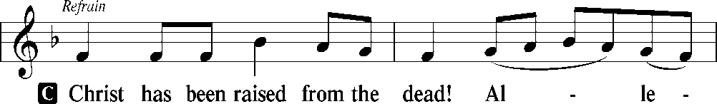
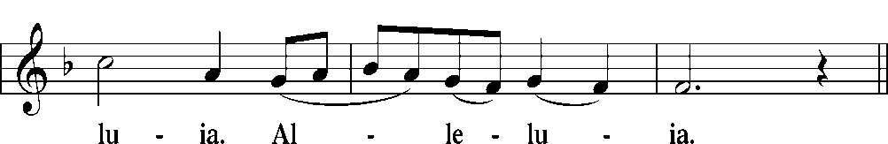
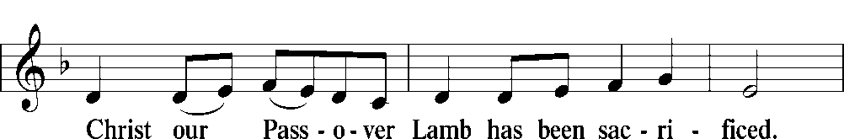
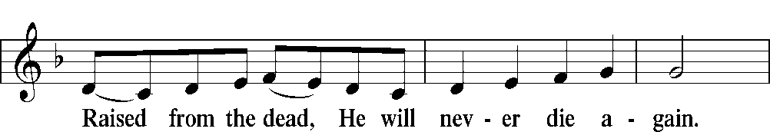
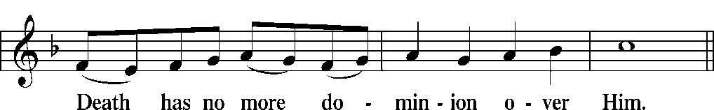
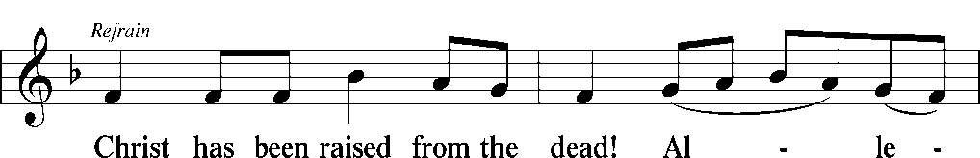
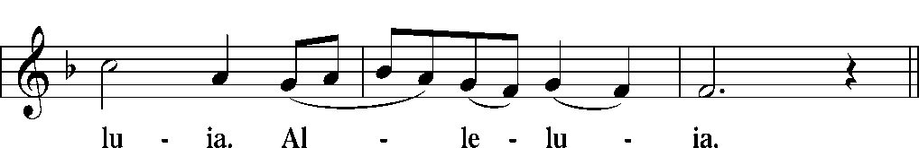
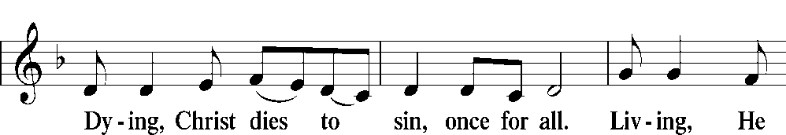
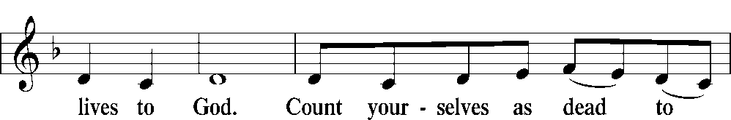
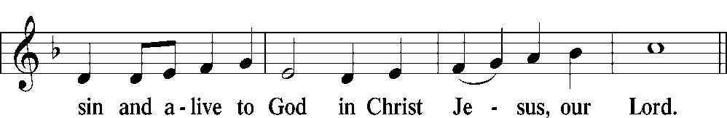
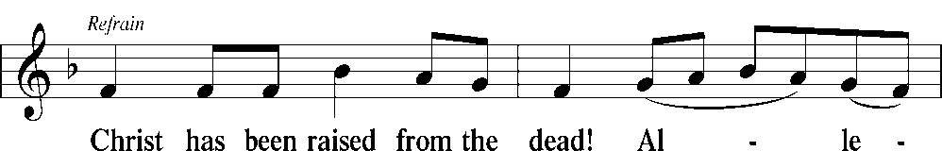
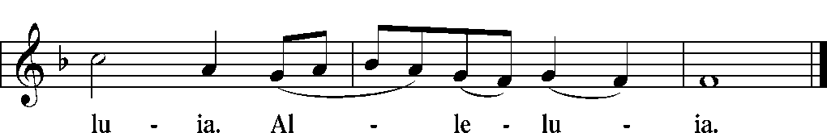

Blessing
P: Let us bless the Lord.
C: Thanks be to God.

P: The almighty and merciful Lord, the Father, the † Son, and the
Holy Spirit, bless and preserve you.
C: Amen.

Closing Hymn: “From All that Dwell Below the Skies” LSB # 816

Prayer at Close of Service…Praise be to You, holy and always merciful Father, for Your ongoing good gifts given to Your people. We especially thank You for sending Rev. Jacobsen and his family to us as our under shepherd. Bless and preserve him and his family as they labor among us for our eternal good and for the furtherance of Your kingdom; through Jesus Christ, Your Son, our Lord. Amen.

Installation of Rev. Adam E. Jacobsen

April 25, 2020

